**WEEK-4**

**SPRING REST USING SPRING BOOT 3**

**SPRING REST HANDS ON – 2**

**Hello World RESTful Web Service**

**CODE:**

**Step 1: Add Spring Web Dependency**

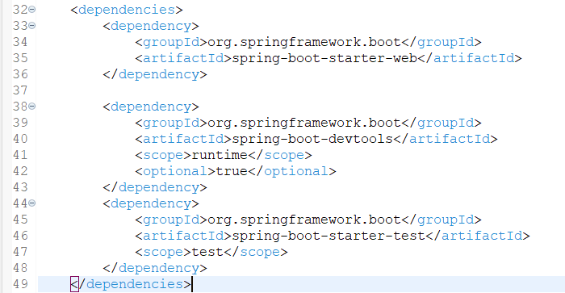

**Step 2: Create the Controller Class**

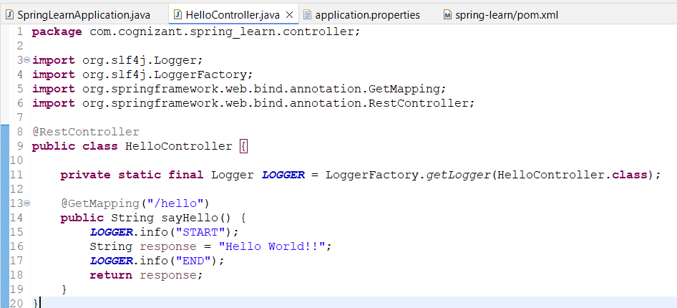

**Step 3: Create SpringLearnApplication.java**

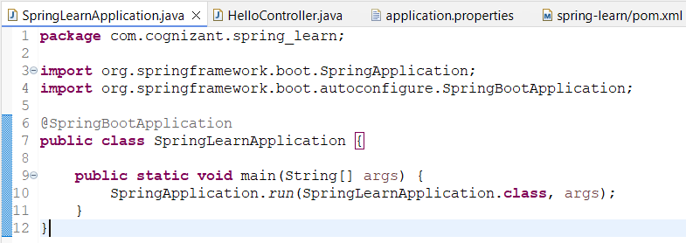

**OUTPUT:**

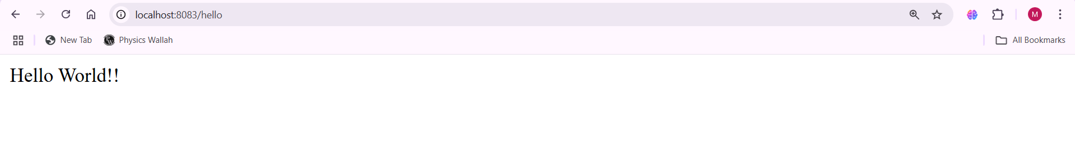**URL http://localhost:8083**

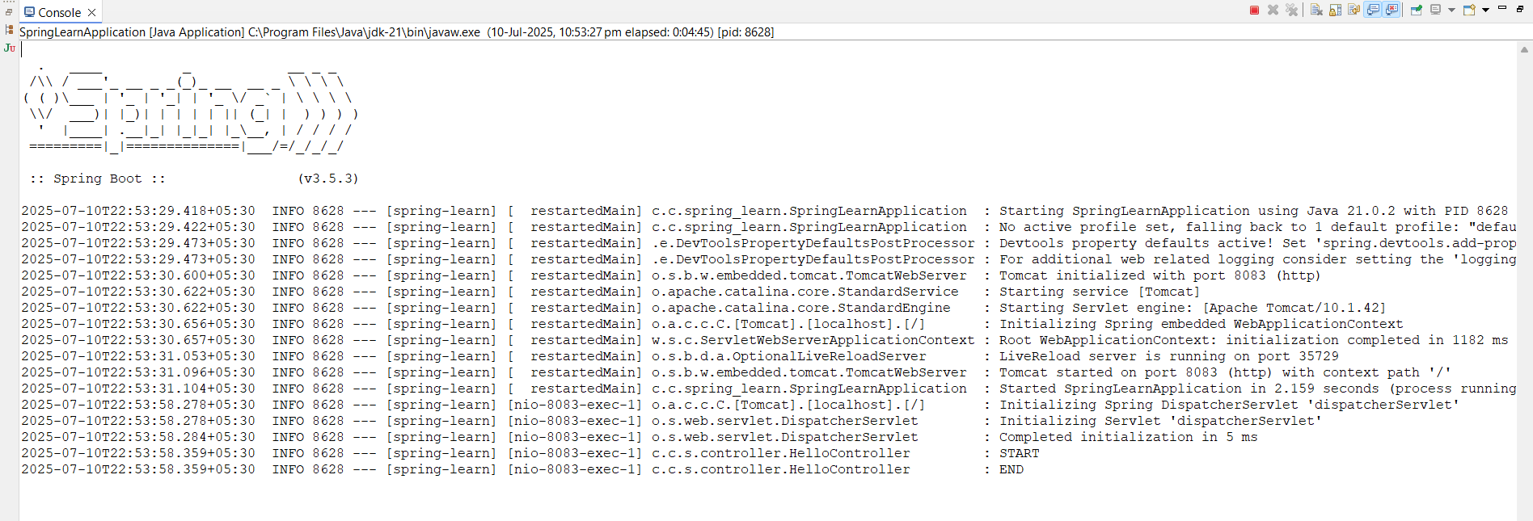**Console Output**

**REST - Country Web Service**

**CODE:**

**Step 1: Define the India Bean in country.xml**

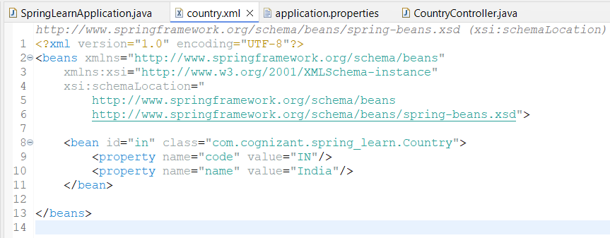

**Step 2: Create Controller Class – CountryController.java inside src/main/java/com.cognizant.spring_learn**

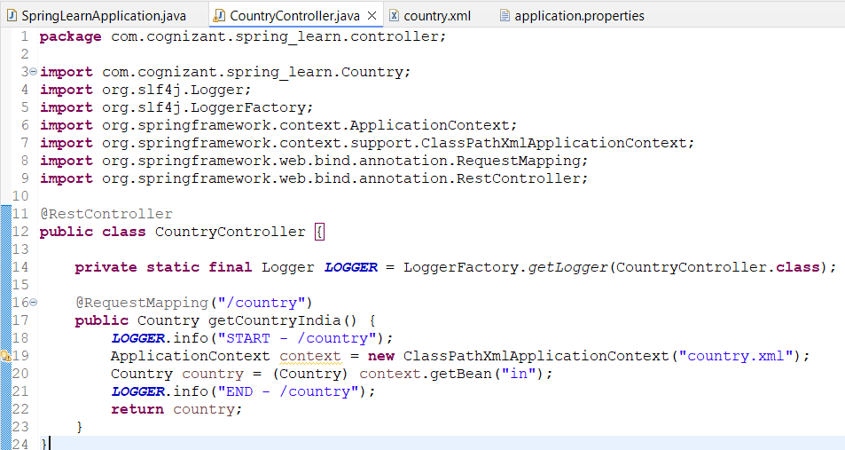

**OUTPUT:**

**Inside URL http://localhost:8084/country**

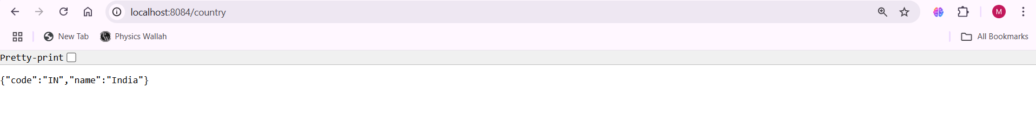

**Console Output**

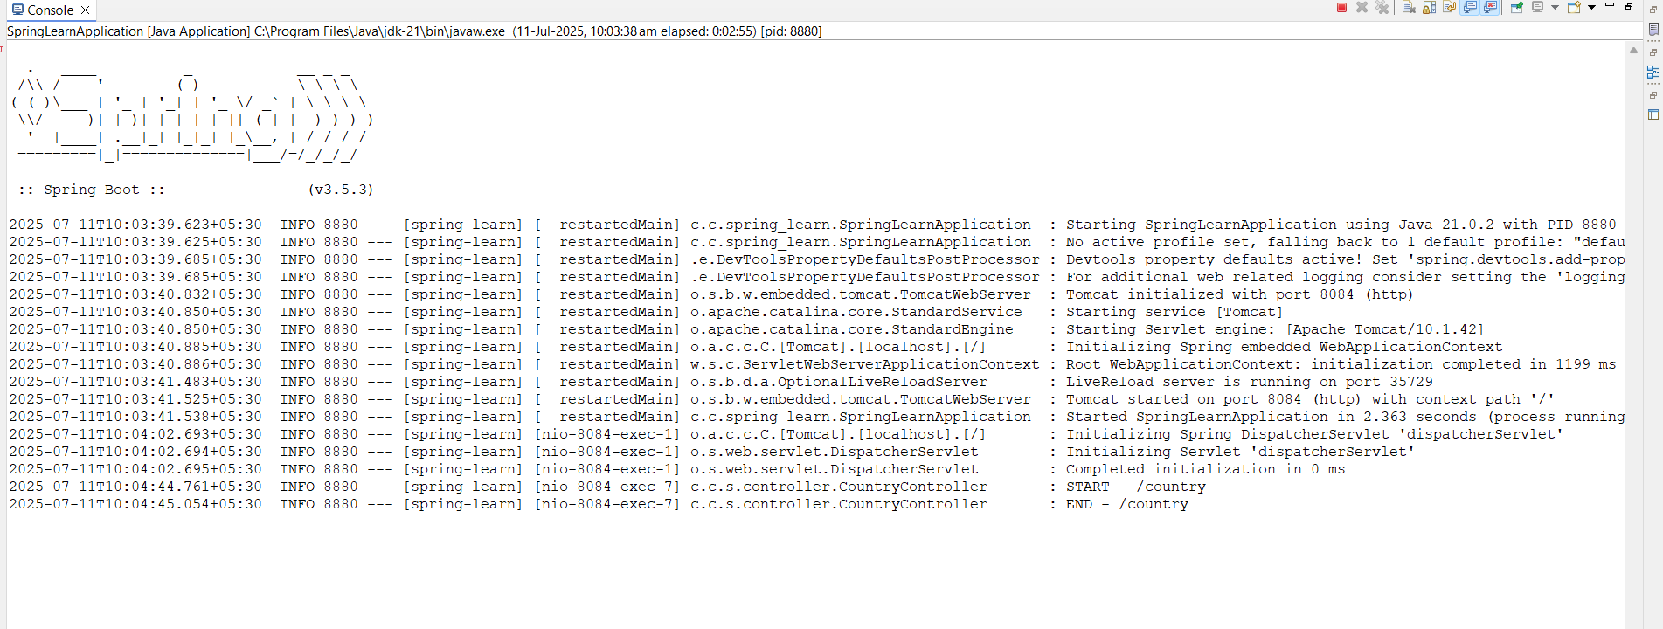

**REST - Get country based on country code**

**CODE:**

**Folder structure**

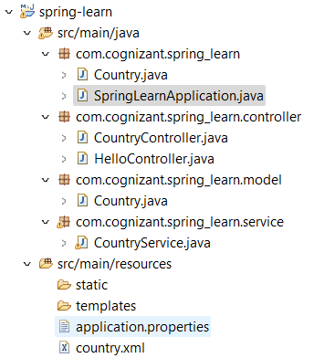

**Step 1: Add the Country Bean in country.xml inside src/main/resources**

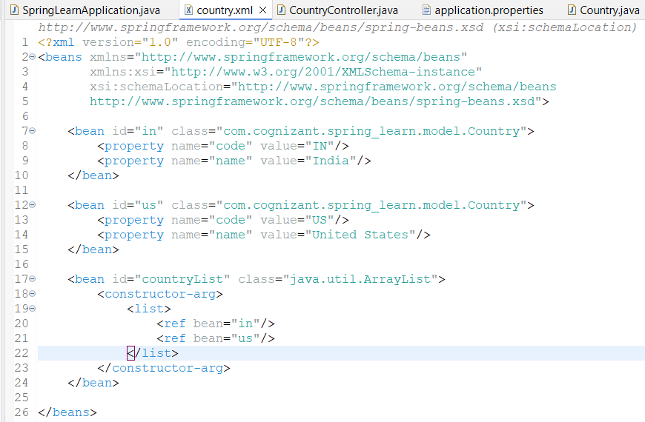

**Step 2: Create Country.java inside in New Package as com.cognizant.spring_learn.model inside src/main/java**

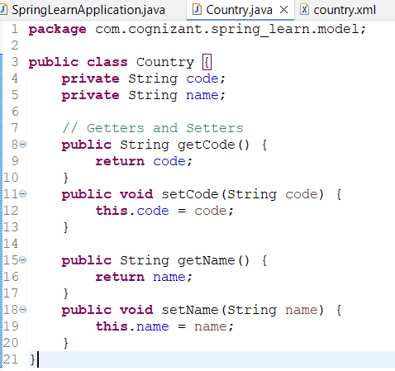

**Step 3: Create CountryService.java inside new Package com.cognizant.spring_learn.service inside src/main/java**

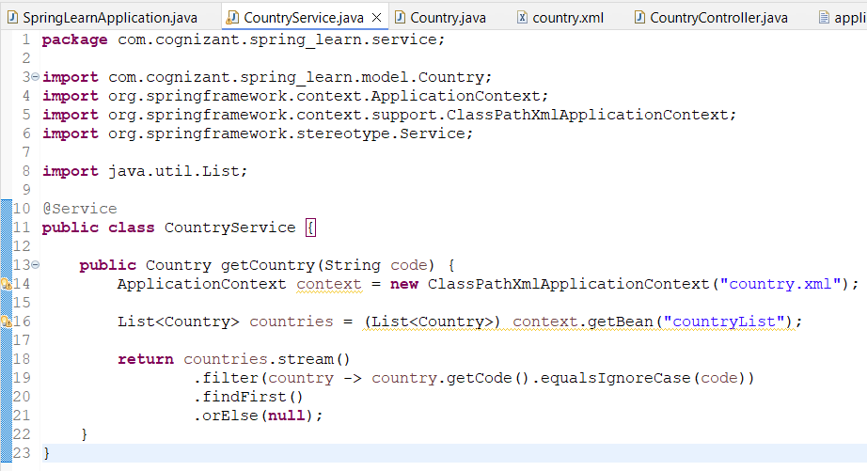

**Step 4: Create CountryController.java inside com.cognizant.spring_learn.controller**

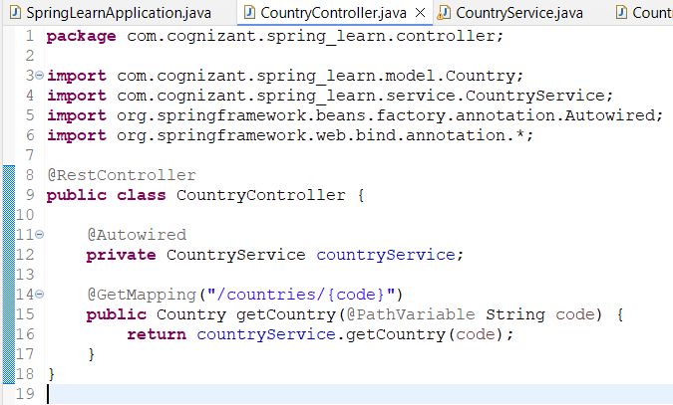

**OUTPUT:**

**Using URL** [**http://localhost:8085/countries/in**](http://localhost:8085/countries/in)

